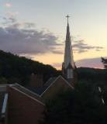

From the Pastor
Let the peoples praise you, O God; let all the peoples praise you. ~Psalm 67:3

As most of you know, we were able to continue with our pattern of a
summer trip with our youth group. We returned to the familiar sands of
Ocean City, MD and two of our previous mission partners, although none
of these you had taken this particular trip previously. Additionally, we added to our partners and projects serving at St. Paul by the Sea Episcopal Church where they have begun an overnight homeless shelter. Praise God for their work, for the people we met there and all along the way, and for the kindness and dedication of our youth who requested an extra day at the shelter, to serve their new friends one more night. ~PBAJ

Seth: This trip meant to me helping and serving other with some added fun mixed in. I have gotten closer to God in realizing that the simplest things can change someone’s life. I have seen him in the homeless peoples’ faces, the beautiful nature on the beach, and experienced his presence in the serving we gave. I have learned that I hate cleaning cat out of a washing machine. I have encountered God’s mercy in the kind reception of our service to others. Thanks for donating to allow us to take this trip. I will be carrying the hermit crabs back home and remember to spend my money wisely.
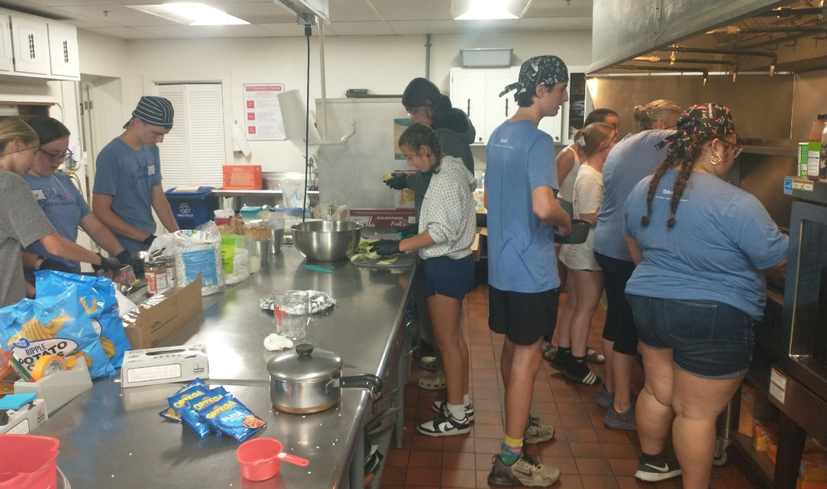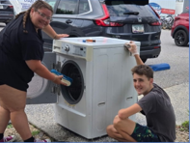
Owen: This trip was an entertaining way to serve God which is why it meant a fair bit to me in that we were given the opportunity to do good things away from home. I got closer to God by seeing that a place like this, where we encountered homeless people, which would not be a normal vacation destination can turn out even better. I have experienced God’s presence by seeing that the majority of people that we met were nice even if they didn’t have the best living conditions. One thing I learned about myself is that open water isn’t that scary. The things I will be carrying with me is that homeless people can be anywhere even in developed places. And also doing flips are easy for me. The thing I would like to tell the community is that they shouldn’t overhype this trip, because doing work under God can and should be done by everyone, everywhere.

St. Peter’s Post 8/1/26
St. Peter’s Lutheran Church

2. Mission Trip | 7. Mission Trip | 12. Financial Facts
3. Mission Trip | 8. St. Peter’s Pride | 13. Thoughts & Prayers
4. Mission Trip | 9. Peach Potluck & Softball | 14. Calendar & W/ELCA
5. Mission Trip | 10. Announcements | 15. Thanks & Volunteers
6. Mission Trip | 11. Announcements & Birthdays | 16. Sponsor Page
Elsa: Our 2026 mission was an amazing experience. From jumping waves on the beach to having evening devotions, we had so much fun. I can very confidently tell you I experienced God’s presence every day.
This trip meant a lot to me because of all the people we helped and made a difference in their day. For example, at the homeless shelter, we made a close friend named Janet. The third day she told us that she was having a bad day, but she told us that we made her day a lot happier. That really stood out to me because we could see how much of an impact we made.
One of my other favorite things was getting to know everyone better. By the end of the trip, we area all super close friends. One of our favorite things to do together was play cards. I feel I have gotten closer to God, too, this trip by realizing how blessed we really are and to not take things for granted.
I have seen God so much on this trip. One of the many examples of his was when we went to the beach for the sunrise the last day. All of us could truly feel and see God all around us. Another example would be our safety, because there were several times where we could have been in an accident or hurt by the waves but God was with us.
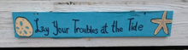
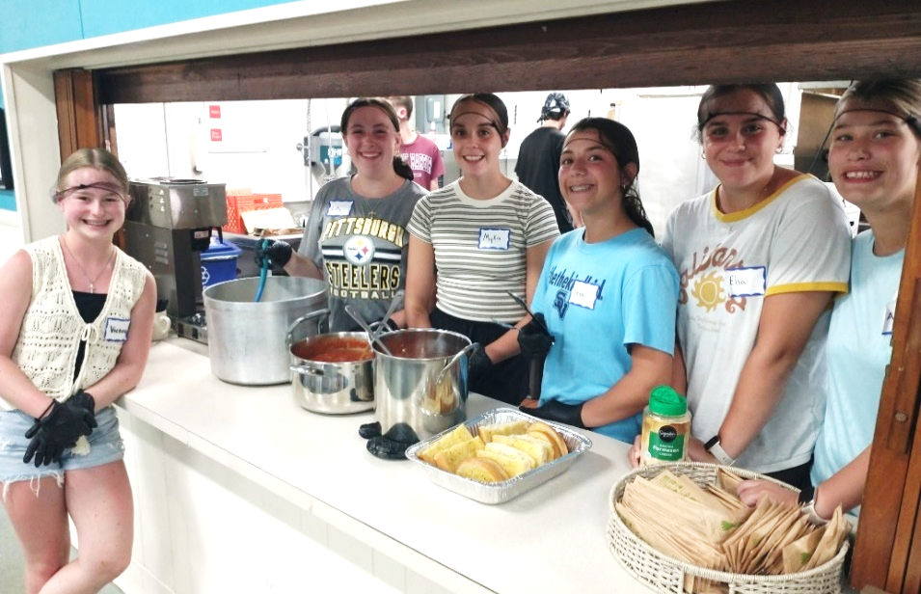
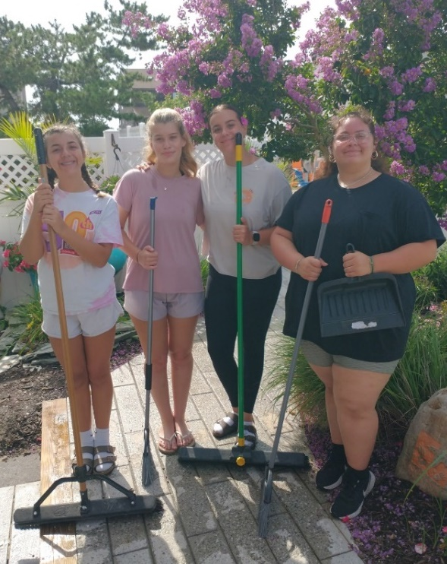
Somethings I will carry with me from the trip are never judge a book by its cover, always depend on God, and people see your work.

Gia: What this trip meant to me was how we made an impact on people’s lives by just talking to them. I have gotten closer to God and church family by spending time together each day and doing devotions each day. I have seen God in each other as we helped people each day. What I have learned about myself is that I can get closer to others by just talking and sharing things I have in common with someone. Some things I will carry along after this trip is how fortunate we are. For example, when we went to the homeless shelter, I noticed some people would wear the same clothes every day, and that shows how we are fortunate and should be grateful for what we have. Something I would like to say to our community back home is that the kindness from your donations allowed us to create memories we will never forget.

Myka: This trip has meant so much to me both physically and spiritually. Not only did I get to know my peers much better, I also got to grow in my relationship with God. I feel his presence in the beautiful scenery and nature around us. Even when getting knocked down by waves time and time again, I could feel God’s protection and power. As for my peers, we all instantly got along well and had fun together. Most of the people that attended this trip I have grown up with, but it wasn’t until this trip that I really got to know them.
I have also seen God in every time we attended the homeless shelter. Everyone there was grateful and happy. Two of the people who made the most impact on me would be Janet and Victoria (a friend who came along). Janet was a very nice member of the community who attended the homeless shelter. She shared her life story and her faith with us. She had grown up in the Catholic Church and she patiently taught us how to preach the gospel to others who might have grown up in different religions, denominations, or faiths. Victoria made a significant impact on me by how she fearlessly preached the gospel. Every conversation and interaction she had with the community was either exemplifying Christ or talking to strangers about Jesus. On this trip, I have learned so much about myself. By watching others, I was able to have conversations with the people at the shelter about Jesus. I also learned to trust God through fearful situations. On the first day, I rode a wave that was definitely too big to be riding. After I hit my head on the bottom of the ocean floor and washed back up on the shore, I was scared and fearful. After getting crushed by many other waves, I realized something. Just like the waves always brought me back to shore, God’s love will always bring me back to him.
There are many things I will carry with me after this trip, but the most important is to never judge a book by its cover. We met a lot of people who I would have classified as scary, but instead we talked to them. In the end, they were really sweet. At the homeless shelter we worked at we served dinners. There were a lot tables set up. One of the tables had a red table cloth. Everyone who had to sit there had made a mistake in their past. I was fortunate to talk to some of those people and I saw how a person who had made a bad decision can turn and repent to Jesus and how they can be totally renewed through his blood. I also learned how important it is to exemplify Christ’s love to others. People were really grateful when we went to the homeless shelter. They kept telling us how we made their day and how we were able to add a little brightness to a really rainy day.
Lastly, I want to show my appreciation for every single one of you, for funding this trip and helping me grow in my faith. I am so grateful I was able to attend and get to know Christ better. Thank you all so much.
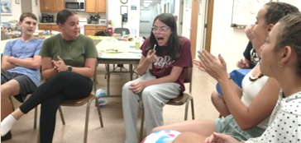
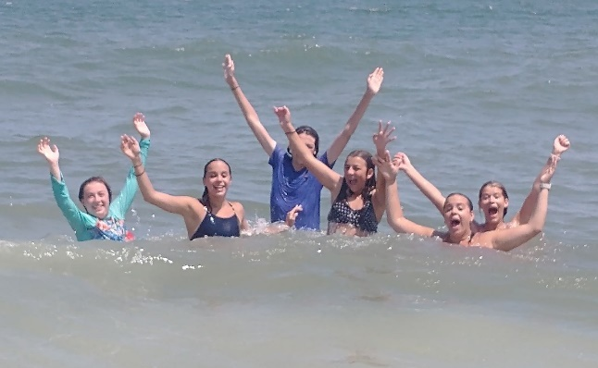

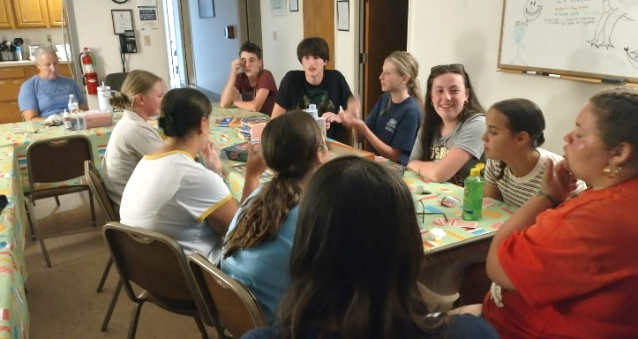

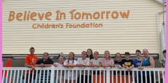

Victoria: On this trip, I learned a lot of new things about myself and others. I grew spiritually, emotionally, and mentally. I also grew in my speaking and I feel this trip was a tiny step out of my comfort zone. I’m grateful that I got to meet new people and grow relationships with them. I also really loved how this trip got me off my phone for the entire week. I also really enjoyed going to the beach for the first time! I also really, really loved sharing the highs and lows and then answering the devotion questions at the end of the day. That was really fun and I felt like I had a voice to speak about myself and also helped me get to know more about others through their answers.
There are so many ways that I grew closer to God and the church family. One of the ways that I grew closer to God was just knowing about his character more. I learned more about God’s character through devotions and although I’ve heard about God’s love time and time again, I’m in constant need of reminders of the character of God. Personally, I didn’t really know many people that come, because I don’t go to this church but I got to build new friendships and make memories with everyone that came and I’m so beyond grateful for that and everyone was so sweet, too.
I feel like on this trip, I was constantly experiencing God’s presence. I saw God through the beauty of the scenery and the beach. I saw God in the people around me. I saw God in the service we provided and the joy brought to those we served. Most of all, I feel I experienced the presence of God when speaking to Janet, because I felt like God really sparked that conversation and the Holy Spirit gave me wisdom and knowledge and spoke through me to her but also God used her to speak to me.
I have learned a lot about myself but I think the biggest ones were related to how social I was. One is that I can talk to complete strangers perfectly fine as long as they are older or younger than me but anyone 10 years of age close to me, I get really frightened by. Secondly, a lot of people, about half that I stayed with, told me that I really changed from the beginning of the trip to like the second day, which to me, is very interesting and I want to look into that more.
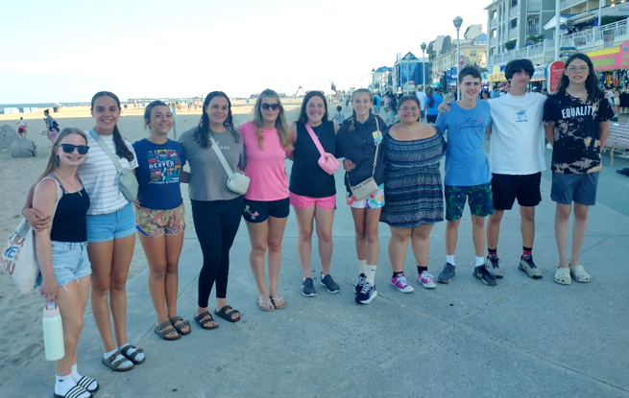
I think the main thing that I will carry with me for a long time is the conversations I had with the homeless people and how insightful they were to me and their wisdom. I will also remember God’s presence with me while I spoke to them about my belief in Jesus. I think that because of his presence, next time I talk about what I believe in, I can have peace that God is with me. The last thing that I want to remember clearly is to pray for the people we meet because someone from the homeless shelter asked me if I believe in prayer. I said yes, and he asked me to pray for all of the people at the shelter. That is something that I will carry with me.
Thank you for all of the amazing memories. Thank you for letting me join in on all the experiences. Thank you all for inviting me into your family on the first day before I could even remember your names. I’m so grateful for everything that happened and for every one of you. Thank you all for the amazing experiences and the amazing first time on a mission trip and at the beach. Jesus loves you!
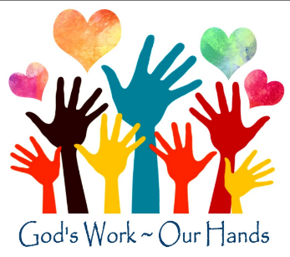
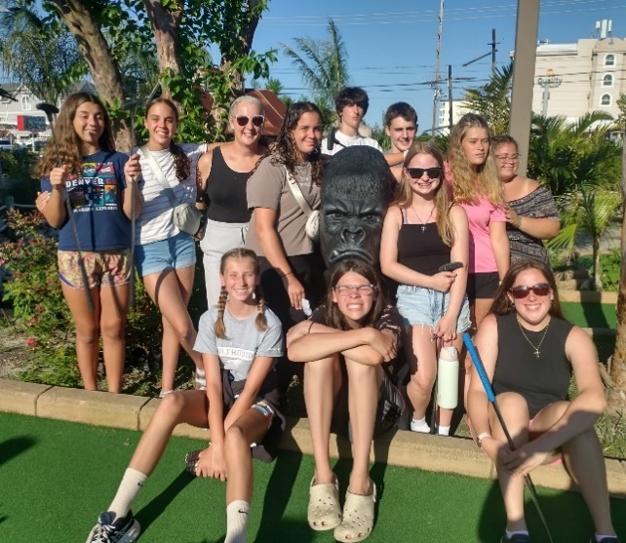
Lily: For me this trip has been an amazing experience. I have wanted to go on this trip for years, and I finally got the opportunity. This trip has shown me things that I can’t see at home. I am so grateful that I got to serve so many people. It felt so amazing seeing my actions pay off first hand, and it is something that I wish everyone got to experience. The fact that we got this awesome opportunity is so incredible. This trip helped me discover that you think you know someone, and then you spend a week with them and realize how little you actually knew. We spent lots of time talking, and it just made me ask myself: How much of others do I really know? We had some conversations that gave us deeper understandings of each other. Similarly to talking to each other, talking about God in devotions and praying during our service gave me a deeper connection with God. Other people shared things I had never thought of before, and it made good discussions and a different way to see God. The deeper my understanding of God is, the closer to him I feel. Also, the analogies and deep questions left me thinking about God and the way He loves. Throughout the trip we met a variety of different people in different situations. Everywhere we went you could see hope because they knew God was with them. We worked at a homeless shelter and had deep conversations about faith with someone. You could tell from the way she talked that God meant very much to her and was helping her through this rough time. Also, in the way Victoria, the youth who started the conversation, talked to her you could see the Holy Spirit putting words to her mouth. This trip also gave me a chance to reflect on myself. I realize that sometimes I can be quick to judge and forget to keep an open mind. When we went to the homeless shelter, I thought it was going to be a bunch of grumpy people, but I quickly realized that they almost all had hope and that they were very happy to see youth doing God‘s will. Not only did that teach me something about myself, it is something that I will take with me for the rest of my life. Another thing that I will take with me, is how much a little act can mean to someone. Just by being there to serve food, weeding, or cleaning a shed you can make a huge impact on someone’s day. I want to finish by saying how much I appreciate this opportunity. Without the community’s support we wouldn’t have been able to serve all of the people we did. This mission trip has changed us all for the better, and it is thanks to you that we could go. If you ever question what you’re giving is actually going ,to just remember all of the people that I have mentioned us helping. Just by eating at a church dinner you’re helping us serve others. I hope you understand how much good that this has done in my life and how thankful I am for this opportunity.
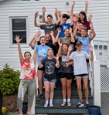

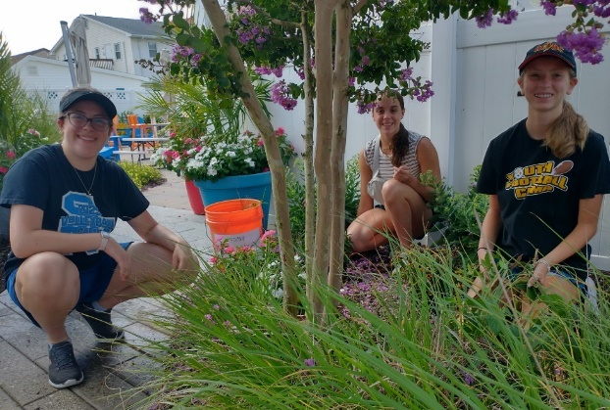

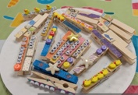
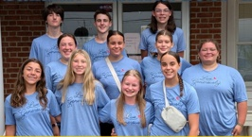
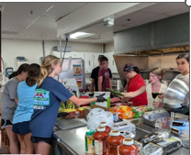
Alyssa: This was my first mission trip. I got an amazing group of kids to serve with. We served at St. Paul’s by the Sea. There we prepared food for those who are going through a rough patch and might need a little help getting back on their feet. I met so many wonderful people and talked to several people there about God. (Specifically, if you wish to speak about Christianity with others who have different beliefs you should attempt to shift your perspective and view Christianity from their point of view to connect with them.) At the shelter I met Janet; she was very nice and talked to us about her past and religion. I saw God in Janet, she was at low point in her life yet continued to be positive. I gave her one of my bracelets and told her it was just an early birthday gift. Her birthday is August 30th so I learned that we were both Virgos which made my day. (It felt like I was meant to give her my bracelet.) We also served at another shelter for those who are in the transition process of getting a home of their own. There I met a very nice gentleman who was discussing football with Pastor. I came over to help weed and ended up talking about football with them too which made me extremely happy. (I play flag football.) Just talking to him for a couple minutes about football and players was probably the highlight of the trip in my opinion, which really goes to show how such a simple conversation can impact someone. (That’s the thing I’m going to carry with me.) This trip has brought me closer to God through daily devotions and sharing where I’ve seen God throughout the day made me acknowledge that H e is always with me. I really appreciate the effort put into make this trip memorable and fun, I met so many wonderful people and made new friends. Thank you!
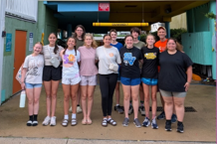

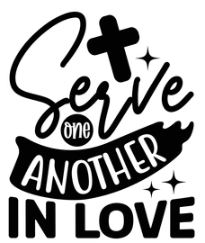

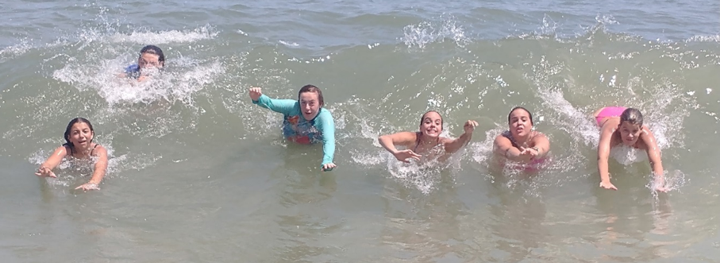


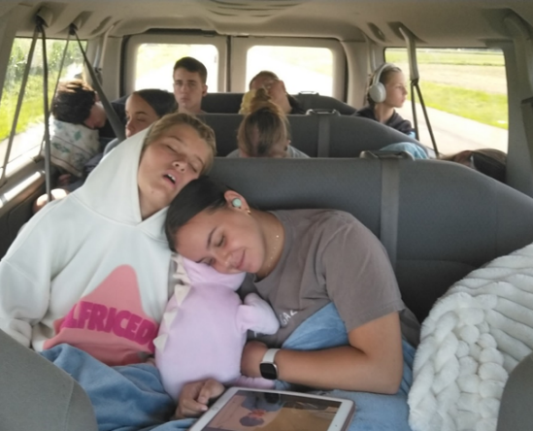
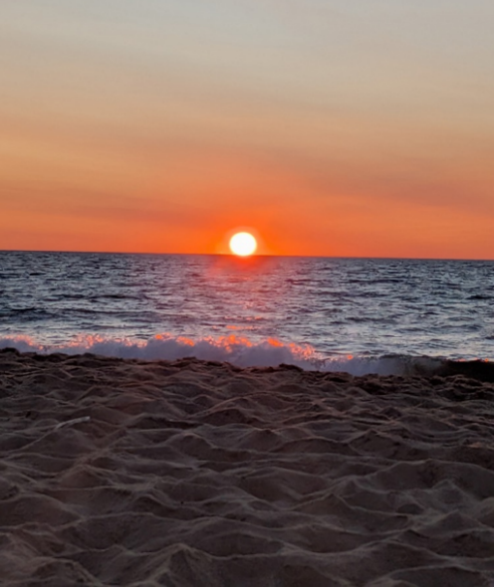
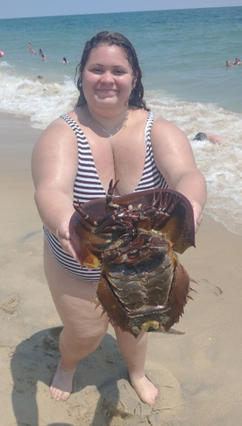

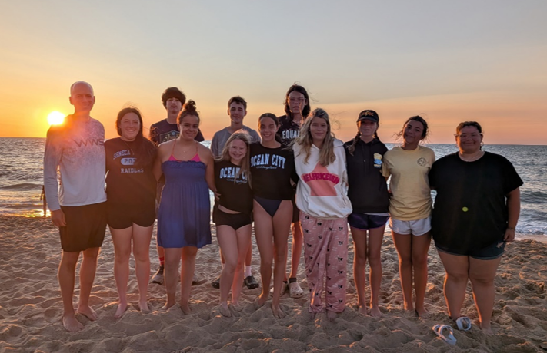

St. Peter’s Pride

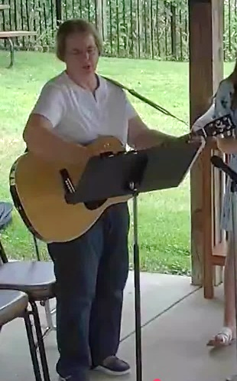
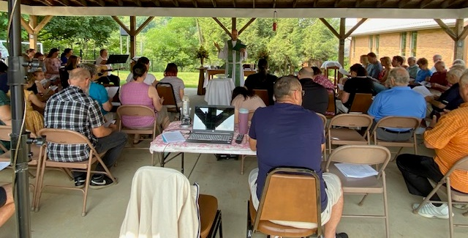
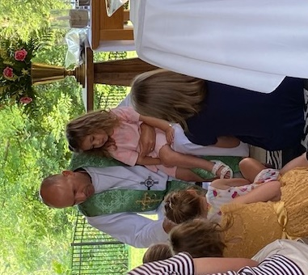
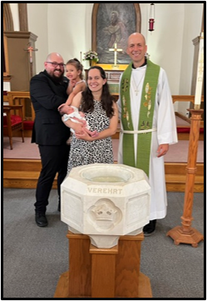
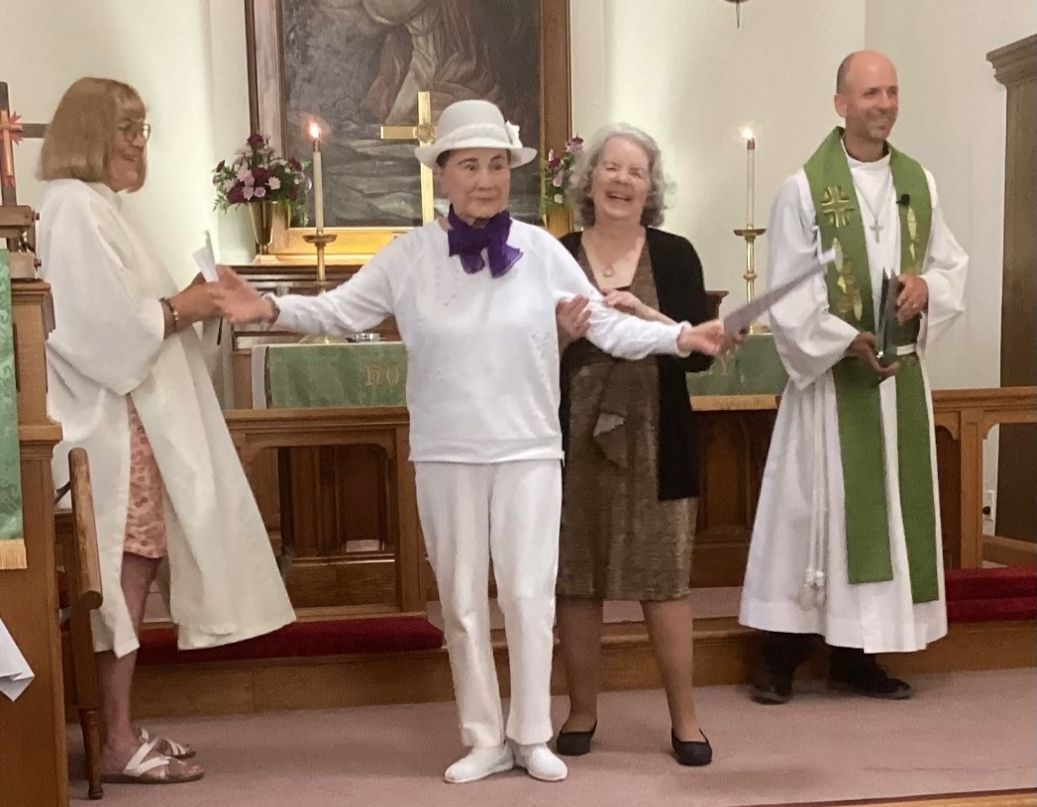
Thank you to Deb Mort for her leadership in this camp style service.
The weather cooperated and we had a wonderful
outdoor service on Sunday, July 26th.
St. Peter’s friends and family welcomed Reece Danielle
as our newest sister in Christ on Sunday, July 19th. Congratulations to proud parents, Casey and Dan, grandparents, Amy & Walt, and great-grandfather, Joe.

We join with Kim Fyock in her joy as we welcome her into our community of faith. She became a member of St. Peter’s on July 12th.
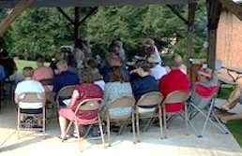
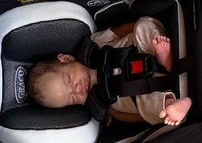

Peach Potluck & Softball News


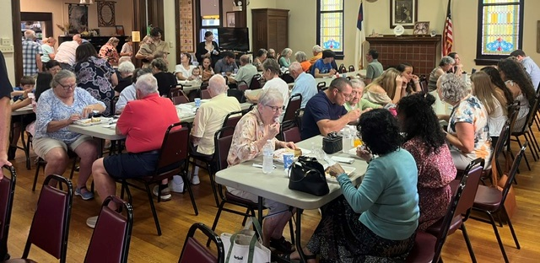

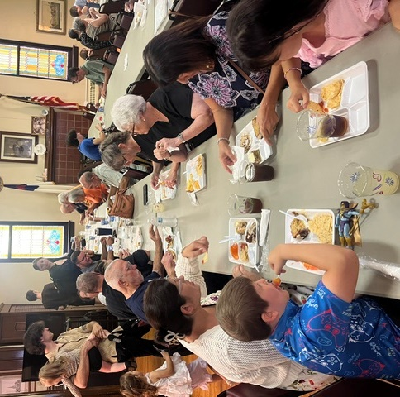
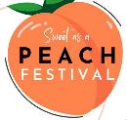
On Sunday, July 19th,
St. Peter’s Fellowship Committee
hosted the annual Peach Festival. The event featured many peach-themed desserts as well as some main dishes and sides! Many friends and family stayed after worship to participate in the event. Thanks to everyone
who took the time to make
things for this potluck and
to all who attended!
Much fun was had by all.

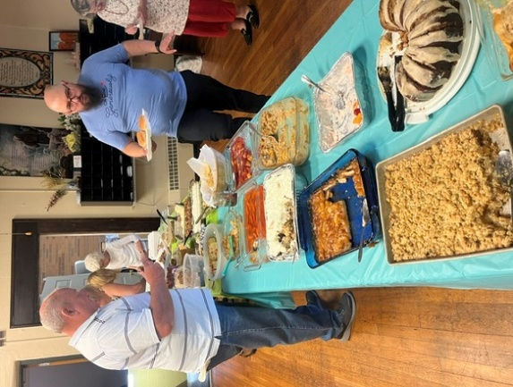


Breaking News!!!
Your St. Peter’s Apostles are in the
Championship of this year’s Softball League.
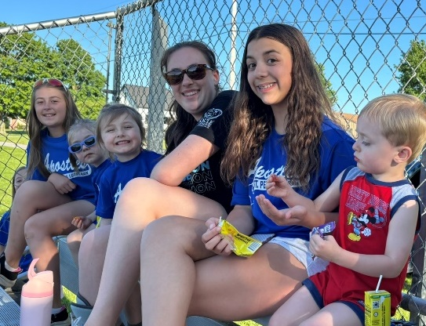
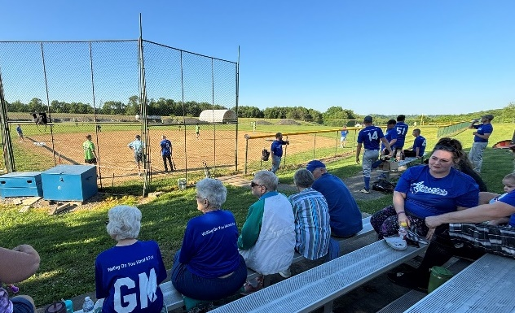
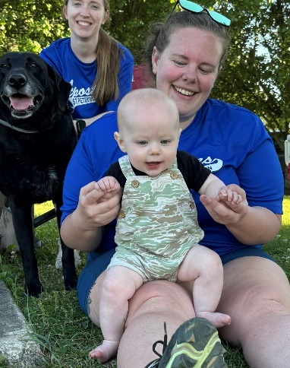
The best-out-of-five series will take place the week of August 9th, so be watching for that announcement so you can come and cheer on our team!


Food Drive – Thank you to everyone who
donated toiletries in July. In August,
we will focus on collecting paper products.
On Thursday, August 6th at 1:00 pm, our Women’s Circle groups will be meeting for a lunch and to string the school kit bags. There are 100 bags, so we welcome your help for the work, but also your company for the fellowship time that comes with joining together in mission and for a nice meal together as well.
National Night Out will be held on Wednesday, August 5th from 6-8 pm at EDCO Park.
The Evans City Community will be celebrating this national event with a free meal
provided by our churches and free access to the pool. We hope to see you there.

Announcements


Join us the 2nd Sunday of each month after worship to pack food for folks in our community in need of a little extra help each month.

500 Card Club – Friday, August 7th at noon.
Everyone is invited and encouraged to attend.
No experience needed! If you would like
to learn to play, you are welcome to join
in the fun. It’s a potluck event so bring
whatever you would like to share.


Join your church family and friends
for our monthly lunch outing

Wednesday, August 12th at 12 pm.
This month’s restaurant is
T. J.’s Hideaway

Anyone is welcome to attend. Please let Pastor Johns know how many will be joining from your party so he can pass the information along to RSVP.


Helen’s Helpers & Nancy’s Needlers
meet once a month to work on sewing service projects. They are currently working on school kit bags and clothing protectors. No experience necessary. There are tasks that can be done by all skill levels. They will not be meeting in August, but join them again September 14th.



Corn Roast – Our annual corn roast will be
held on Saturday, August 15th at 5:30 pm.
Please bring a side dish or dessert to share.
The night’s fun will include rounds of Bingo with prizes.

Immigration Conversation – A group of members of our church community are interested in having thoughtful, graceful discussion around the topic of Immigration. All who are interested are invited to come next Sunday, 8/16, before worship at 9:15 to take part. SuLan Peebles, daughter of our most recent new member, Kim Fyock, will help to facilitate that conversation. SuLan is an immigrant from Taiwan and was a special agent for Immigration and Customs Enforcement for 26 years before retiring in 2011, and received awards from various other federal agencies.

Back to School Blessing – Mark your calendars today for the Back-to-School Blessing
that will be held on Sunday, August 16th during our worship service. Children are welcome to bring their backpacks and/or school supplies as we will pray for students, teachers, and families as they look forward to the upcoming 2026-27 school year.



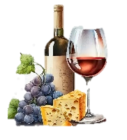

Wine and Cheese – Join us Saturday, August 23rd at 6:30 pm at the Raupp’s for an evening of relaxation as we casually play some games, take in delightful conversation, snack on hors d'oeuvres, sip some adult beverages, and maybe even go for a dip. Hope to see you at there!

More Announcements & Birthdays



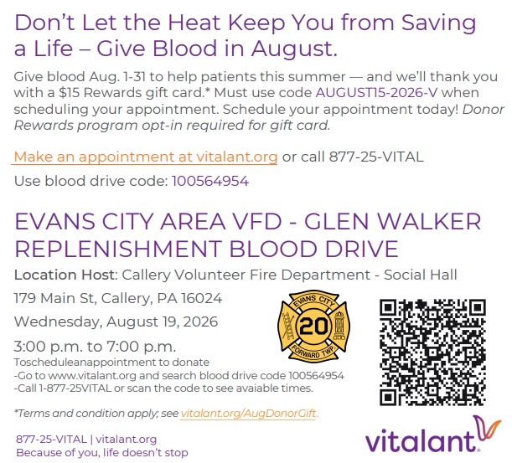



Saturday, October 10th
Time: 1:00 pm
Cost: $70/adult ticket*
$54/child ticket*
*tickets include buffet style meal
Only 5 tickets left!

This year we are attending The Ohio Star Theater
at Dutch Valley, Sugarcreek, Ohio.
Please see the sign up in Luther Hall.
There are only 5 preordered tickets left.
We are still far enough out that we could reach out to inquire about more, so please let us know now if you would like to go.
Please consider participating in
this upcoming blood drive
and then mark your calendars for
Monday, October 26th when we
will hold our annual blood drive.
**Shhh…Special Announcement**
Surprise Card Shower for Kay Burr's 90th Birthday
on September 2nd.
Mail Cards to: Kay Burr
1252 Prospect Road
Prospect, PA 16052

St. Peter’s Church Family Wishes
Many Blessings to You

1 Logan Thomas 18 Carol McKinnis
3 Lisa Burr 18 Madalyn Rajchel
4 Corey Walker 18 Benson VanDyke
6 Cathy Kistler 19 Neal Critchlow
6 Summer Barron 20 Michael Bettencourt
7 Marge Wearing 21 R.J. Bird
7 Davin Beahm Jr. 23 Katie Weber
12 Brittany Green 26 Charles C. Harbaugh
14 Lindsay Jason 27 Alyssa Mossor
30 Lynn Schweingruber

APPLE FEST
The Apple Fest is coming soon,
and many donations are needed to make this event possible. Please save the dates below to volunteer, and have fun and fellowship
during our annual event!
Apple Fest:
Sept. 18th & 19st
Dumpling Making:
Sat. Aug. 29 at 8:00 am
Dumpling Making:
Sat. Sept. 5 at 8:00 am
Apple Cutting for Apple Butter:
Fri. Sept. 11 at 8:30 am
Apple Butter Making:
Sat. Sept. 12 at 5:00 am - 3 pm?

Financial Facts
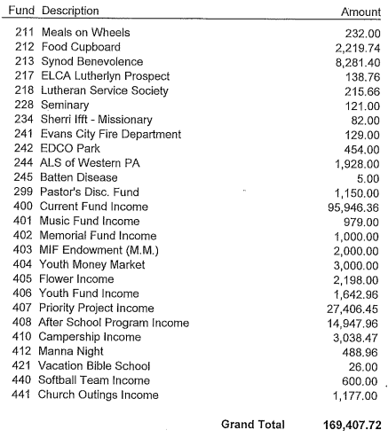
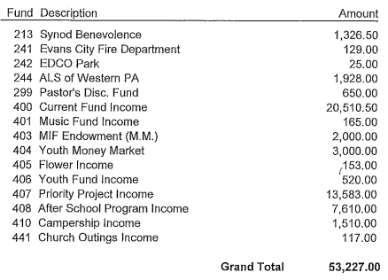

Our Monthly Benevolent
Cause for May will support
Lutheran Campus Ministries
If you would like to support
this cause please mark the
“Other” line on your contribution envelope.

June 2026 Contributions:
2026 Contributions to Date:
If you are interested in sponsoring altar flowers,
we still have opportunities available in
August, September, November, and
December. Please see the posted
flower chart in Luther Hall to sign up.

A Financial Update – To keep everyone informed
about our current financial situation, the
reconciled treasurers report of our current fund
as of the end of June 2026 is as follows:

Current Fund $8,423.30
Memorial Fund $11,497.05
Youth Fund $10,401.22
Manna Fund $6,907.61
Priority Project Fund $17,832.90
After School Program $12,593.85



So far in 2026 we have completed at least 25 projects utilizing Thrivent Action Team cards. That’s $6,250 provided by Thrivent as seed money for the work of our congregation! Thank you to those who have led projects to support our mission. Reach out to the office if you
would like assistance developing
a project to use your Thrivent cards.

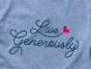
WELCA SCHOOL KITS
We have had great response so far towards meeting our goal of collecting enough supplies for 100 kits, so thank you to everyone who has donated already! There are just a few items still needed to reach our goal, so check out the poster.
Please bring all items to the church by
Sunday, September 6th.


Our contributions to Meals-on-wheels
continues through the first two weeks of August.
Thank you to all who are helping to serve in this way.

Thoughts and Prayers

Diane Marburger
Joe Marburger
Patty Marburger
Jane Mashuda
Diamond McCracken
Berty McMillen
Cole Moretti (Cancer)
Carmen and Sandra Morra
Kerren Morra
Mark Phillips
Emma Plank
Jason Plank
Erin Price
Bill Puryear (Cancer)
Lori Rasp
Rick Reifenstein
Tammi Rossi
Dominick Scarpino
Pastor Tony Schneck
Kay Marburger Terry
Julie W
Garrie Wearing
Marshall White
Matthew Wible
Roland Wise
Pat Wolfe
Audray Muscatello Yost

Beverly Barkley
Cole Barkley
John, Summer, Timothy Barron & Family
Peter Barry
Debbie Beahm
Ricky Benson
Tom Broeren
Eilene Budisky
Kay Burr
Lisa Burr
Arlene Cameron
Jane Carruth (Colon Cancer - B.Barkley)
Luke Clawson
Donna Daugherty
David English (Lung Cancer)
Diane Fair
Michelle Follet & Family
Mary, Glenn, and David Fulghum
Lori Goodwin
Patti Grubbs
Joan Gumpp
Richard Hutchins (Cancer)
Annastyn Hogan
Stephanie Hogan
Ella Jason
Greg John
Val Kurth (Breast Cancer)
Todd Manuel (Blood Cancer)





PRAYERS FOR OUR HOMEBOUND
Please contact the church office as soon as possible
to request additions or changes.
Gini Rinkus
Nancy Zattiero



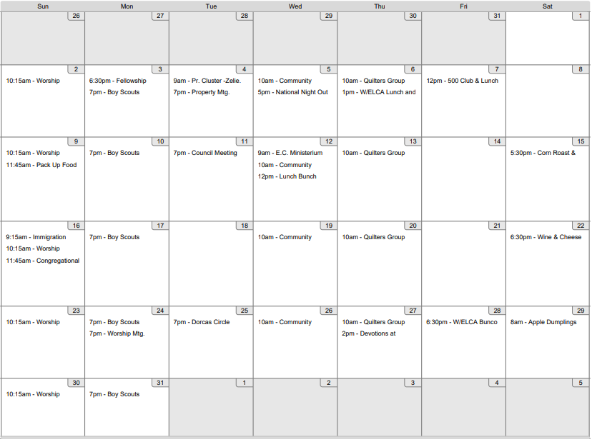
If you ever wonder about any of the events or projects that you hear about under the umbrella of W/ELCA or Circle or our St. Peter’s church women, please ask one of us. We encourage you to join us for the various activities we do throughout each month and we are interested in trying new things to bring us together as sisters in Christ, so please don’t hesitate to talk to us about ways you might like to be involved.

Calendar & WELCA Highlights


Dates to remember


8/6 – Lunch and stringing bags
8/25 – Dorcas Circle – Bible study meeting at church this month
8/28 – Bunco Night – Look for a sign up next week
** Every Thursday our quilters meet upstairs in the quilting room.

All skill levels welcome
It’s time to register for the SWPA & NWPA Retreat, Sept. 25-27th at camp Lutherlyn. You can find more information and register by going to the SWPA synod’s website. If you need any assistance finding info or registering, please speak to Teresa O’Malley or contact the office.

Thank Yous & Volunteers
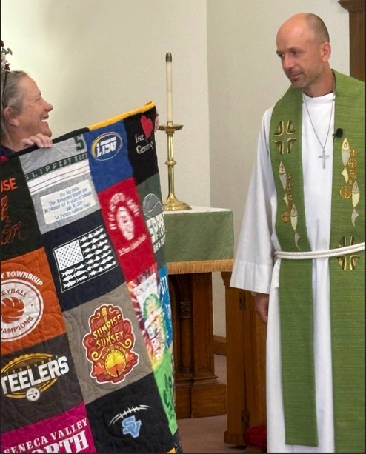


We write with heartfelt gratitude for your continued support and partnership. Thank you for your generosity and for your belief in the transformative power of theological education.
Conor Brooks
United Lutheran Seminary

Thank you, St. Peter’s for letting us use the
church for our program with the rain scare.
Evans City Historical Society


Many of our St. Peter’s youth were able to enjoy faith and fun-filled weeks at camp this summer due to the support
Thank you to the congregation, especially the quilters, who made such a special keepsake for Pastor Johns to celebrate 10 years here and 15 years of ordination.
of this congregation. Thank you from our camper families.
Look forward to some photos in next month’s newsletter.

T
H
A
N
K
Y
O
U

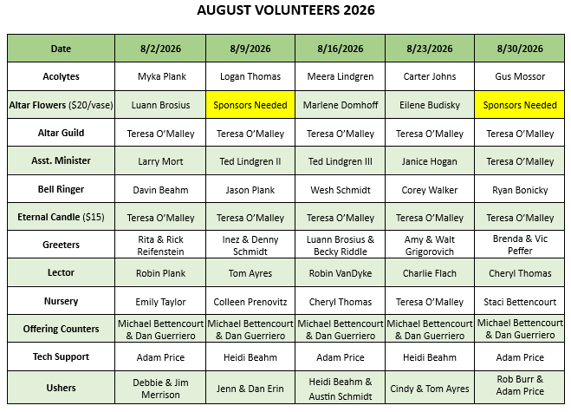


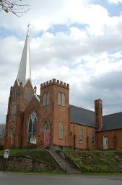

• The Sunday Bulletin Deadline is Wednesdays at 10 am
• Monthly Newsletter Deadline is
the 3rd Sunday of each month
• Summer Book Study: 9:15 am (Sundays in July)
• Weekly Worship Services:
Sundays at 10:15 am
• Check Our Weekly Calendar of other events.
• Summer Office Hours
M-W-F (9am—noon)

August 2026
Newsletter
St. Peter’s
Lutheran Church
202 Van Buren St.
Evans City, PA
16033

Call us: 724-538-5810
E-mail us stpeterslcec@zoominternet.net

God’s Son

Never Fails
Website: www.stpeterslutheranevanscity.org
Our Staff:

Pastor Brandon Johns

Heidi Beahm,
After School Director

Marlene Domhoff,
Organist / Music Director

Joe Ludwik, Sexton

Christine Johns, Secretary

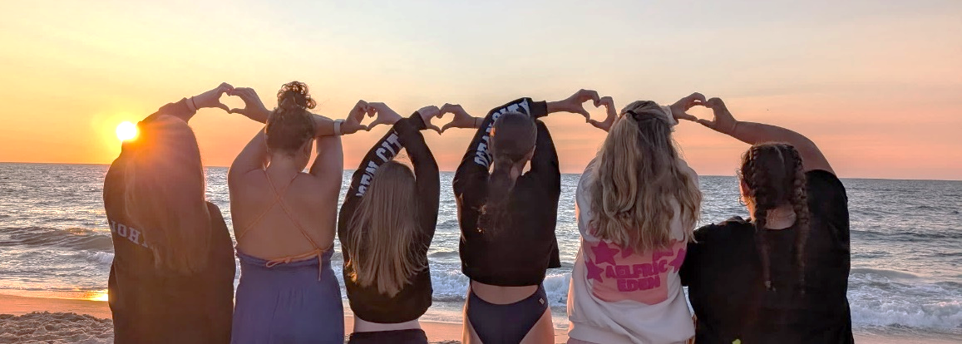

This month’s newsletter is sponsored by
Marlene Domhoff
in honor of RJ Bird’s Birthday.

